CHAPTER-1
INTRODUCTION
In today’s modern lifestyle, stress has become a major part. Due to changing lifestyle and food habits, there are various health issues. One of the main threats to human life is the cardiac problems. Cardiac arrest, arrhythmias and dysrhythmias are some of the common medical complications witnessed in humans. The human heart contracts and expands in a rhythmic fashion, pushing the deoxygenated and oxygenated blood in and out respectively. The sinoatrial node is responsible for this contraction and expansion. It provides electrical impulses to the heart, enabling it to contract and expand. Thus, the sinoatrial node acts as a natural pace maker.
1.1 Need for Defibrillators
It is seen that, the number of victims for cardiac arrest and arrhythmias is increasing in an exponential manner. According to the survey conducted by the Australian Institute of Health and Welfare, it is reported that there are increasing number of victims for cardiac arrest.
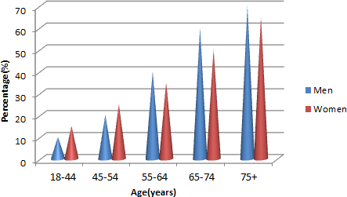
Fig. 1.1. Victims for Cardiac Arrest
It is to be accepted that, a well-equipped health care sector is an indicator of the development of the nation’s economy. It is very important to analyze the mortality rate in a particular nation and make necessary remedial measures to increase the lifespan of the nation’s citizens. It is a bitter reality that, most of the victims for cardiac arrest face death because of the lack of immediate medical assistance. Immediate medical assistance can save the victim. The response time after the cardiac arrest is really crucial, because the brain cells suffer lack of oxygen and the cells begin to die within few seconds after cardiac arrest. Hence it is inevitable to defibrillate the heart, to bring it back to normal operation. Defibrillator is an electronic equipment that can be used to revive the functioning of the heart by delivering a pulse of electric shock. The sudden shock will help the heart to regain its natural pace.
It is very important to install defibrillators in public places, so that the victims can be treated as soon as possible. It is also seen that most of the public places have defibrillators installed so that emergency needs of the public can be adhered to. Defibrillation is an immediate remedy to cardiac fibrillation eliminating the need of surgery and hence we need defibrillators in the evolving modern society. Modern lifestyle and changing food habits are the major reasons for the exponential rise in the cardiac arrest victims all over the world. The normal functioning of human heart is explained below. Sinoatrial node is responsible for the normal functioning of the human heart. Fig. 1.2 shows the functioning of sinoatrial node. Age related fibrosis can cause sinoatrial dysfunction, a condition where the sinoatrial node fails to give proper rhythmic impulses to the heart. When this happens, the rhythm of the heart is not stabilized, leading to a condition called arrhythmias. It is extremely important in bringing back the natural pace of the heart.
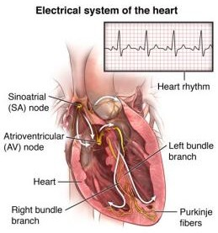

Fig. 1.2. Function of sinoatrial node in a human heart.
Defibrillators are one of the best ways to bring back the rhythm of the heart since they are quick enough, and the process of defibrillation, does not require any surgical procedures. Defibrillators are used to give electrical impulses to the heart, when the sinoatrial node malfunctions. In short, a defibrillator is an ersatz sinoatrial node.

CHAPTER-2
LITERATURE SURVEY
2.1 A Pulsed Low-Frequency Physiotherapy Device
A. Yu. Zaslavskii et al presents the soft tissues are the dense fibrous connective tissues that include tendons ligaments, fascia, and muscles that connect and support the organ of the body. Tendons and ligaments are mostly subjected to injuries in sports person and person who regularly practicing exercise that may lead to tendon and ligament rupture which limit the activities of daily living. The results of experimental studies and medical trials of INFITA-M, a pulsed low-frequency physiotherapy device, are presented. The INFITA-M device therapeutic pulsed low-frequency electromagnetic fields of nonthermal intensity with a predominant electrical component. The results of measurements of the strength of the pulsed low-frequency electromagnetic field in the therapeutic zone are presented for the cases of remote and local treatment. Medical trials confirmed the efficacy of the INFITA-M device.

2.2 Low-Frequency Ultrasound Therapeutic Device For Soft Tissue Healing
Uma sankari Vasagaraj et al presents the Therapeutic ultrasound has been studied and used for the past seven decades to treat musculoskeletal injuries. Recently, a significant body of animal and human research has focused on the biomechanical effects of daily-applied, low intensity therapeutic ultrasound (LITUS) on soft tissue recovery. We performed a systematic review of the last two decades of LITUS literature to examine the effects on tendon, skeletal muscle, ligament, and tendon-bone junction injuries. LITUS facilitated tendon healing, with increased tensile strength and improved collagen alignment. For skeletal muscle and ligament injuries, LITUS increased cell proliferation during generation and improved tissue biomechanics (ultimate load, stiffness, energy absorption). LITUS aided tendon-bone junction healing through improved tissue function. Scientific evidence supports the use of LITUS to treat soft tissue injuries, and improve outcomes for musculoskeletal injuries and post-operative recovery. Lastly, we discuss the use of LITUS devices facilitating daily applied therapy in the home setting.
2.3 Metrological Characterization of Therapeutic Devices for Pressure Wave Therapy: Force, Energy Density, and Waveform Evaluation
Akash et al presents the Pressure wave therapy is widespread for multiple purposes, from cell metabolism stimulation to tendons, ligaments, muscles, and bones pathologies treatment. However, in the literature, there are no quantitative metrological data related to pressure wave devices. On the contrary, it would be extremely important to have more information on the provided therapeutic signal. which could also be exploited as input for a finite-element model able to foresee the pressure wave propagation inside the tissues. The authors investigated three different versions of the same device in terms of force applied to the tissue. The results show high variability of the pulses intensities (up to 25%), highlighting a nonuniformity of the treatment (in particular at low frequencies and high compressed air pressure). Moreover, the dependence from different parameters (i.e., pulse frequency, pressure, opening time of the solenoid valve for the compressed air pushing the bullet) was investigated. It was found that the lower the frequency and the higher the opening time of the valve, the higher the force applied to the tissue. An estimation of energy density was done; sometimes the limit values provided by pressure wave therapy guidelines.
2.4 Fabrication of SU-8 based Capacitive Micromachined Ultrasonic Transducer for low frequency therapeutic applications
Shiv Govind Singh20 et al presents the simple post-CMOS compatible sacrificial release method of fabricating SU-8 based Capacitive Micromachined Ultrasonic Transducer (CMUT) for low frequency therapeutic applications. CMUTs fabricated with Silicon Nitride and Silicon Dioxide lay constraints in terms of area and power consumption especially in the low frequency range. Fabrication of these devices need complex high temperature processes that makes them incompatible for post-CMOS processing. Analytical modeling shows that SU-8 based CMUT consumes less area (below 25%) and power compared to Silicon Nitride and Silicon Dioxide based CMUTs. The proposed fabrication method overcomes inherent disadvantages of sacrificial release method by providing uniformity in air gap and reducing the possibility of stiction.
2.5 Therapy device for hand joint movements
Watcharin Saracha et al presents the rehabilitation of people losing the ability to perform all or part of the upper limb joint movements, especially in hand at the level of the phalanges, carpal and wrist; caused by degenerative or traumatic diseases, in which affected the movements of flexion-extension, rotation; we designed a simple device for therapy, which allows the patient self-employment. Currently, angular measurement tests are conducted with adult patients without pathologies and with congenital and degenerative diseases of the hand, to create a model based on the needs of the adult population in Colombia.

2.6 Versatile Large-Signal High-Frequency Arbitrary Waveform Generator Using GaN Devices
M Revanth Priyanka et al presents the Waveform generators are required for a wide range of application including industrial and biomedical areas. Traditionally, these systems usually aimed at generating high frequency signals but with low amplitude levels, making them unfeasible for large-signal real operation analysis. Advances in wide bandgap semiconductors together with digital control enables the design of new systems. This paper presents the design of a 2000-V versatile large-signal high-frequency arbitrary waveform generator taking advantage of GaN devices. The proposed system has been designed and implemented, proving the feasibility of this proposal.
2.7 In-hospital cardiac arrest: incidence, prognosis and possible measures to improve survival.
Claudio Sandroni et al presents the Medical literature on in-hospital cardiac arrest (IHCA) was reviewed to summarise (a) the incidence of and survival after IHCA, (b) major prognostic factors, (c) possible interventions to improve survival. The incidence of IHCA is rarely reported in the literature. Values range between 1 and 5 events per 1,000 hospital admissions, or 0.175 events/bed annually. Reported survival to hospital discharge varies from 0% to 42%, the most common range being between 15% and 20%. Pre-arrest prognostic factors: the prognostic value of age is controversial. Among comorbidities, sepsis, cancer, renal failure and homebound lifestyle are significantly associated with poor survival. However, pre-arrest morbidity scores have not yet been prospectively validated as instruments to predict failure to survive after IHCA. Intra-arrest factors: ventricular fibrillation/ventricular tachycardia (VF/VT) as the first recorded rhythm and a shorter interval between IHCA and cardiopulmonary resuscitation or defibrillation are associated with higher survival. However, VF/VT is present in only 25–35% of IHCAs. Short-term survival is also higher in patients resuscitated with chest compression rates above 80/min. Interventions likely to improve survival include: early recognition and stabilisation of patients at risk of IHCA to enable prevention, faster and better in-hospital resuscitation and early defibrillation. Mild therapeutic hypothermia is effective as post-arrest treatment of out-of-hospital cardiac arrest due to VF/VT, but its benefit after IHCA and after cardiac arrest with non-VF/VT rhythms has not been clearly demonstrated.

2.8 Acute heart failure and cardiogenic shock: a multidisciplinary practical guidance
A.Mebazaa et al presents the Acute heart failure (AHF) causes high burden of mortality, morbidity, and repeated hospitalizations worldwide. This guidance paper describes the tailored treatment approaches of different clinical scenarios of AHF and CS, focusing on the needs of professionals working in intensive care settings. Acute heart failure (AHF) is the most frequent cause of unscheduled hospital admissions; however, the mechanisms of heart failure decompensation are still unclear, and trials on novel pharmacological agents have been consistently negative. As stated by recent guidelines, physicians in charge of AHF often manage patients based only on expert opinion with insufficient evidence [1]. Indeed, most AHF therapies, including diuretics, vasodilators, inotropes, and vasopressors, are used despite lack of evidence on their impact on dyspnea or on outcome. Furthermore, AHF is managed by a variety of health care professionals including emergency physicians, intensivists, cardiologists, internal medicine physicians, and nurses who each may have a different opinion on the management strategy. Cooperation and homogenisation of AHF management are, however, key in improving the outcome of these patients.
2.9 Paper-based analytical devices for clinical diagnosis: recent advances in the fabrication techniques and sensing mechanisms

Mazhar Sher et al presents the applications including disease diagnostics, environmental monitoring, food safety, and water testing at the point-of-care (POC) settings. Current diagnostic assays available in the developed world require sophisticated laboratory infrastructure and expensive reagents. Hence, they are not suitable for resource-constrained settings with limited financial resources, basic health infrastructure, and few trained technicians. Cellulose and flexible transparency paper-based analytical devices have demonstrated enormous potential for developing robust, inexpensive and portable devices for disease diagnostics. These devices offer promising solutions to disease management in resource-constrained settings where the vast majority of the population cannot afford expensive and highly sophisticated treatment options.

CHAPTER-3
EXISTING SYSTEM
This chapter describes the existing method on therapy device for defibrillator.
3.1 External Defibrillators
External defibrillators are the conventional devices, which are being employed in hospitals. When there is an event of a cardiac arrest, the patient is immediately given electrical shock in the chest, using electrical pads. The electrical pad is often intact with a monitoring machine, which shows the ECG of the person, to determine the intensity of the arrest and to decide the level of electrical shock that has to be given. These kinds of external defibrillators are often found in public places [1]. The disadvantage of this type of defibrillator is that, often an experienced person is required to handle this device. Fig. 3.1 shows an external defibrillator.

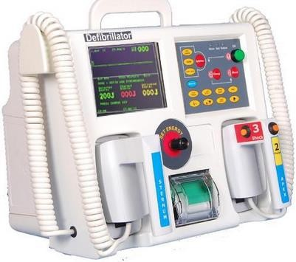

Fig. 3.1. An external defibrillator.

3.2 Implantable Cardioverter Defibrillator (ICD)
Another interesting class of defibrillators is the implantable cardiovascular defibrillator. It is capable of doing defibrillation as well as cardioversion. Defibrillation is the process of reviving the heart, by delivering a strong electric shock, bringing back the pulse. It is done, when the pulse rate of the person goes really down, a massive cardiac arrest. Cardioversion is the process of bringing back the rhythm of the heart to normal sinoatrial rhythm. This is done, when there is abnormal heart beat rate. ICDs are battery powered devices, which contain a pulse generator, almost to the size of the pocket watch. It is often place under the skin near the collar bone or in the abdomen. Leads run from the pulse generator, to the chambers of the heart, as shown in fig.3.2.
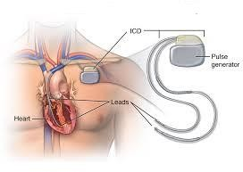
Fig. 3.2. An Implantable Cardioverter Defibrillator.
Since the device is implanted in the body, care must be taken to provide an efficient battery, since changing the battery will need a surgical procedure [1]. Often lithium batteries which have a long life are used, but it is extremely important to have regular checkups should happen every few months, to monitor the battery life. One of the drawbacks of the ICD is that, ICDs are electronic devices, and are vulnerable to electromagnetic interference. If the person with ICD gets exposed to electromagnetic waves that are present in the environment, they are possibilities that the implanted device can malfunction.
3.3 In-Hospital Wearable Defibrillator (IHWD)
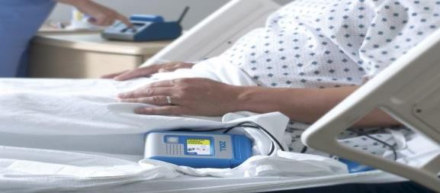
For patients with higher prospect of cardiac arrest, recurrent Ventricular Fibrillation (VF - a condition, wherein the heart rate is very high and irregular) and Ventricular Tachycardias (VT - a condition where the heart rhythm is very rapid, but regular originating from the ventricles of the heart), it is very essential to monitor the heart rate closely and provide immediate defibrillation [3]. In such cases, an in hospital wearable defibrillator is used. For a patient experiencing VT/VF, every minute is important and the defibrillation should be done as soon as possible shown in Fig. 3.3

Fig. 3.3. In-hospital wearable Defibrillator.
It is employed for patients, who are at a higher risk of getting continuous fibrillations in the heart. It is meant for in - hospital use only and is under close monitoring of the doctors and medical assistants. The device is designed to deliver the electrical impulse, within 60 seconds.
3.4 Smart Wearable cardioverter defibrillator (SWCD)
One of the recent advancements in the field of wearable defibrillators is the wearable cardioverter defibrillator. It is a device that can be used by a person with a higher risk of getting a cardiac arrest. It is worn under clothing, and the device works by continuously monitoring the ECG signals of the person. If an abnormal rhythm is detected, then the SWCD alerts the person by sounding an alarm. After that, the SWCD delivers an electrical shock to restore the normal heart rhythm.
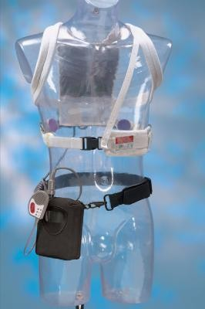
A typical SWCD is shown in Fig. 3.4, Fig. 3.5 shows the parts of an SWCD. It consists of two self -gelling pads which are in contact with the chest. The device also has few dry ECG electrodes, which continuously monitor the ECG level of the person and signals the response buttons, in case of any abnormal heart rate. When the ECG goes abnormal, a signal is sent to the main monitoring device that triggers the operation of the electronic pads, thereby delivering an appropriate electric shock.

Fig. 3.4. Smart Wearable Cardioverter Defibrillator
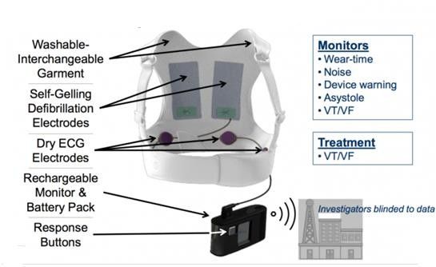
Fig. 3.5. Parts of an SWCD
It is also intended to treat VT/VF patients, but the difference between in hospital wearable defibrillators and the smart wearable defibrillators is that, SWCD is quite self- standing and can work without the assistance of anyone. But the in-hospital wearable is under close monitoring of medical assistants. This is because, though the in-hospital wearable can give electrical shocks by itself, it is employed for patients with very critical VT/VF and hence monitoring the level of shock is inevitable, as the patient's condition can worsen at any time. It is very important to design an efficient and cost-effective SWCD which will increase the lifetime of patients with cardiac problems [14-15]. Further, the paper will deal with the aspects of SWCDs and their importance in the current scenario in detail after comparing SWCD with other types of defibrillators that are currently in use.

3.5 COMPARISON OF DEFIBRILLATORS
A comparison between the various types of defibrillators is depicted below.
Table 3.1. Comparison between various types of defibrillators
S.NO | ED | ICD | SWCD
1 | ED is an external system that provides an electrical shock to restore a normal rhythm | The shock is delivered to the heart from inside the body by an ICD. | A shock is delivered to the heart by a wearable jacket from outside the body by SWCD.
2 | The electrodes are attached to a monitor and AED acts as a stand-alone device, which should be used to deliver electric shock. | The electrodes run to the chambers of the heart, from a pulse generator that is implanted under the skin. | The wearable jacket contains the pads, which are in contact with the chest.
3 | These external defibrillators can be used, only after detected acardiacarrest. | The shock is given automatically after detecting an abnormal heartrate. | The electric shock is given immediately after the ECG signals are found to be abnormal, by the ECG electrodes.
4 | Requires the help of a skilled person to defibrillate. | Since the device is in vivo, no need for any skilled person. | The jacket is wearable and hence the patient is alerted before delivering the shock and then shock is delivered.
5 | Might be battery powered or connected to direct power source and replacing batteries is an easy task. | Highly efficient batteries are needed, since the device is implanted and changing of th battery needs surgery. | The SWCDs do not require very high efficient batteries, since the batteries in the wearable canbe easily replaced.

CHAPTER 4
PROPOSED SYSTEM
4.1 SMART WEARABLE CARDIOVERTER DEFIBRILLATOR
The Smart Wearable Cardioverter Defibrillator (SWCD) is a cutting edge technology in the field of defibrillators [31]. They are really flexible in terms of usage, because they are like garments and are worn under clothing. They are various parts in a wearable defibrillator unit.
4.2 Dry ECG Measuring Patch
There are dry ECG measuring patches that are placed on the inner side of wearable jacket, and are used for continuous monitoring of the ECG signals[31]. The patches send the signals to the monitoring machine, and the monitoring machine has control algorithms which upon receiving the ECG, analyses them and gives a signal to the electric pads and the pad delivers an electric pulse accordingly to relieve the arrythmias. An illustration of the placement of ECG patches in the wearable garment is shown in Fig. 4.1.
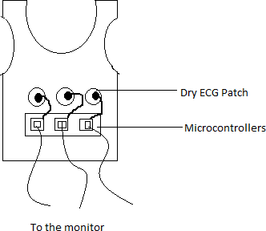

Fig. 4.1. ECG Patch assembly in the SWCD
4.3 Rechargeable Monitor & Battery Pack
The monitor and assembly pack is the decision making unit. It is fed with the decision making algorithm. It can also have a RAM to store the ECG data of the patient, so that the doctors can have a track of the patient’s heart rate [32-34]. This is the main part of the SWCD. It is also very efficient to have SWCDs with disposable energy packs. It might include, low-cost components including non-rechargeable batteries and a memory chip, to store the ECG signals of the patients [35] shown in Fig. 4.2.

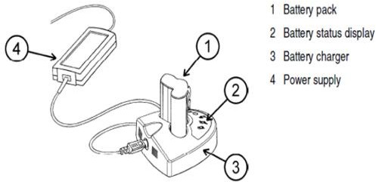

Fig. 4.2 Parts of the monitor and battery pack

4.4 Indicator and Buttons
There are indicators to alert the user, regarding the situation, in case of any sudden arrythmias [38]. They are mainly meant for the ease of the user, so that the user is aware about the electric impulse that will be delivered in a short while. The response buttons also have the provision to indicate the battery life, and the indicators also show the action of defibrillation. There is one another indicator to depict the normal mode of operation of the defibrillator. The power button is provided to help the user to power on the defibrillator and to power it off, while not wearing the SWCD [39] shown in Fig. 4.3.
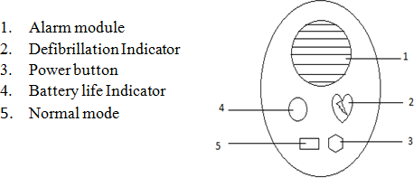

Fig. 4.3. Alarm Module and the Response Buttons

4.5 Alarm Module
The SWCD is also supposed to contain an alarm module. The main reason for this will become evident, if the importance of having an alert system is elucidated. It is seen that, when fibrillation occurs, an unconscious state will ensue after fifteen to twenty seconds. It is very essential for the patient to be aware of the fibrillation. It is because, if the patient is involved in any physical activity like driving, it is essential that warning has to be given to him regarding the fibrillation, so that the patient takes necessary measures, such as parking the vehicle nearby, to prevent from getting hurt in case an unconscious state occurs [36-37]. It is also helpful, because, the patient can visit the doctor after stabilizing to have a checkup.

4.6 Defibrillation Electrodes
These defibrillating electrodes are in contact with the chest of the patient. It is connected to the monitor. In case of arrhythmias, the monitor sends a signal to the electrodes and the electrodes deliver a pulse of electric shock accordingly. One of the major advantages of these electrodes is that, they need not be gelled every time they are in use. They are either pre-gelled at the time of manufacturing, or they might be dry electrodes, which can start operating instantaneously. As an improvisation, it is suggested that two extra electrodes can be used to monitor the respiration levels of the patient, so that Cardiopulmonary Resuscitation can be given to the patient, so that adequate oxygen supply for the brain is ensured. This assembly of defibrillation electrodes will make the SWCD to have four electrodes. This facilitates better operation [40]. This is inevitable since, brain cells get damaged within seconds, if the oxygen supply to the brain is cut. It is to be noted that these electrodes are continuously intact with the patient’s chest.
4.7 Control Algorithm
The most vital part of the SWCD is the control algorithm which controls the overall operation of the defibrillator. The state diagram of a typical SWCD is shown in fig. 4.4.
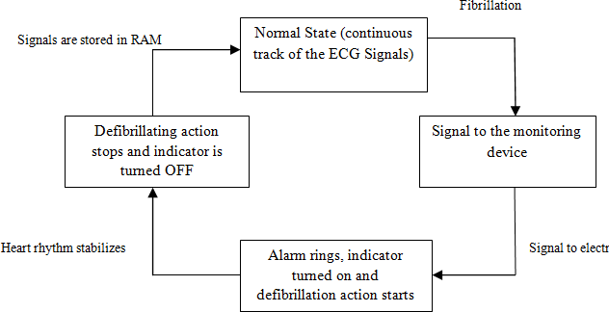

Fig. 4.4. State Diagram of SWCD
The control algorithm of SWCD should be efficient, so that the pacing is done according to the heart rate of the person. The control circuitry must establish heart rate relevant pacing. The control circuitry should be able to differentiate between normal heart rate and arrhythmias. The control circuitry contains as sense amplifier. The data from the ECG patches are sent to the sense amplifier. The sense amplifier contains three major parts. It has an automatic gain control amplifier, a filter circuit and the quad comparator. The automatic gain control amplifier maintains a constant output gain for a specified range of inputs. This range will be the normal range of the human heart rate.
The gain control amplifier will have a different range of output for the input levels other than the normal range of heart rate. The output is then sent to the filter circuit to remove unwanted spikes and for smoothing the signal. Then the output from filter is sent to the quad comparator [41]. A reference signal is given to one of the input terminals of the comparator and the other input is the output from the filter stage. The reference stage contains the nominal heart rate value.
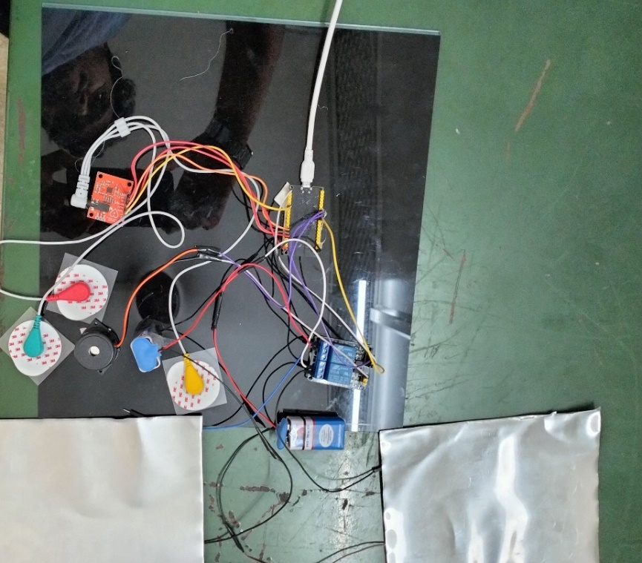

Fig. 4.5. SWCD Prototype
The comparator output is then utilized to know the level of variation in the heart rate and it if fed to a microprocessor which will variably adjust the pulse generator in generating the electric impulses [41]. The generated pulse is then sent to the electric pads and they deliver the shock to the patient. The amount of electric shock should be sufficient enough to help the myocardial tissue to regain its original sinus pace. It is very important that the electric shock should not be very high, since it might damage the cardiac tissues. Often very intelligent control algorithms need to be employed to prevent the event of unnecessary shocks, as a survey [42] has reported patients have reported unnecessary shocks, without the event of fibrillations. The prototype of the SWCD is shown in Fig. 4.5.

CHAPTER 5
SHOCK WAVEFORM
5.1 THE SHOCK WAVEFORM IN SWCD DEFIBRILLATION
The electric shock given for defibrillation is the output because of the capacitor. It is very important to note that the shocking pulse should be sharp enough to stabilize the rhythm and not a slowly decaying exponential one [46]. But the conventional capacitor discharge voltage is a slowly decaying one. The conventional capacitor discharge has a low-voltage trailing edge, which is not desired for defibrillation. This is because the low voltage trailing edge is not efficient in delivering the strong shock that is capable of stabilizing the arrhythmias. Experiments have proven that, only truncated capacitor discharge waveform is efficient enough in treating arrhythmias.
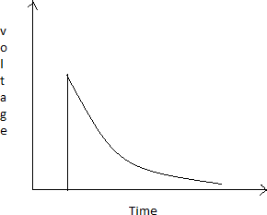

Fig. 5.1. Exponential Discharge of Capacitor.

So the trailing edge should be cut down after a particular period of time. The conventional capacitor discharge and the abridged capacitor discharge waveform are shown in fig. 5.1.
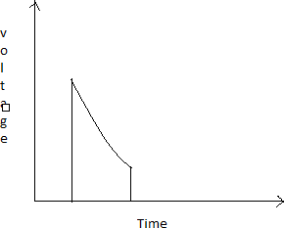

Fig. 5.2. Truncated Discharge of Capacitor.

5.2 TYPES OF SHOCKS IN SWCD DEFIBRILLATION
The electric shock given for defibrillation in SWCD is classified into two major types - Monophasic and Biphasic.
5.3 Monophasic Electric Shock
The monophasic electric shock requires more energy. In this, the current travels only in one direction. There is only positive half of the pulse and there is no negative half for it. Since there is only a high positive peak, chances are there for heart tissue damage. In this type of electric shock, the current flow is from one electrode to the other and the polarities of the electrodes remain the same [43].
Since a high voltage of single polarity is involved in this type of shock, it might cause trauma. The monophasic waveform is similar to the truncated capacitor discharge as shown in Fig. 5.2.

5.4 Biphasic Electric Shock
The biphasic electric shock is the recent method that is being employed in the defibrillator [44-45]. It has two phases of electric shocks, of opposite polarity. Each phase has is having fixed time duration. The time duration of the first phase is greater than the time duration of the second phase. The magnitude of the first pulse is also greater than the magnitude of the second phase. The energy requirement of this biphasic shock is lesser, comparing the monophasic waveform.

The current flows in both directions in this type of shock. The patch electrodes are attached to the position, where the ventricles are present. The patch on the left ventricle acts as the cathode during the first phase of the electric shock and it acts as the anode in the second phase of the electric shock [49]. The electrodes change their polarity for every phase of the shock. Chances of heart tissue damage is less in this type of shock, because it consumes less energy and hence, the probability for trauma occurrence is also very less. It is also reported that, the defibrillation thresholds for biphasic waveforms is lesser than the monophasic waveforms [49]. The biphasic waveform is also an abridged capacitor discharge waveform, but with both half cycles. The Biphasic shock waveform is shown in fig. 5.3.

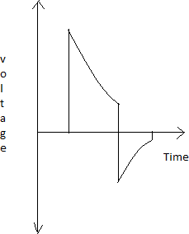

Fig. 5.3. Truncated Biphasic Shock Waveform.

5.5 COMPARISON BETWEEN THE TWO SHOCKING SCHEMES

Though the Monophasic and Biphasic shocks serve the purpose of defibrillating, there are certain notable differences in the impact of these shocks in the human body. It is also very important to monitor the post defibrillation myocardial function after the shock. To emphasize this, a study that is illustrated in [48] shows that, a survey was conducted among the patients with out of hospital cardiac arrest, and the success rate was measured in the case of administering monophasic and biphasic electric shock. It was seen in the survey results that, after defibrillation, the myocardial function was found to be normal in most of the cases after the biphasic electric shock, comparing the monophasic shock. It was seen that the success rate of out of hospital cardiac arrest defibrillation was higher in truncated biphasic electric shock than monophasic electric shock [48].
Another interesting analysis was done on twenty anesthetized pigs to know the success rate of monophasic and biphasic defibrillation [47]. The analysis in [47] stated that the pigs were anesthetized and fibrillation was artificially induced to those pigs. The fibrillation was given to them by supplying AC current to the endocardium. On the onset of fibrillation, randomly ten pigs were selected and were subjected to monophasic defibrillation and the rest were subjected to truncated biphasic defibrillation. The results showed that 8 out of 10 pigs which were given monophasic shock survived the fibrillation and all 10 pigs survived the fibrillation in case of biphasic shock. This clearly indicates that, the biphasic electric shock is very efficient than the monophasic shock. The result depicted in [47] also shows that the myocardial tissue damage was very less in case of biphasic electric shock.
A graph depicting the success rate of monophasic and biphasic electric shock, based on the amount of energy given in joules is fig. 5.4. The data for the graph was from the analysis elucidated in [50]. From the graph, it can be inferred that the biphasic scheme is really efficient in terms of success rate since it has a higher success ratio for low energy shocks itself. So, there will be less damage to the tissues in heart. Hence the design of the SWCD will be utilizing the biphasic defibrillation scheme only. Since it is a wearable, it is advantageous to have a low energy scheme.

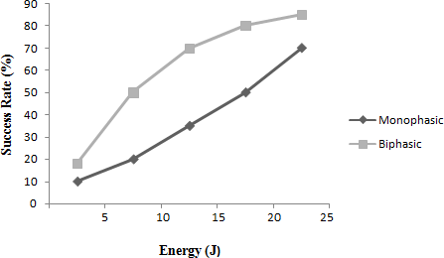

Fig. 5.4. Success rate Vs Energy for Monophasic and Biphasic Shocks
TABLE 5.1. Comparison between monophasic and biphasic shock

S.No | Monophasic Shock | Biphasic Shock
1 | Unidirectional current flow. | Bidirectional current flow.
2 | High energy shocking scheme. | Low energy shocking scheme.
3 | First shock success rate is low. | First shock success rate is comparatively high.
4 | Chances of damaging the myocardial tissues are high. | Comparatively less chances for myocardial tissue damage.
5 | It causes more trauma. | It causes less trauma.

CHAPTER 6
IMPLEMENTATION OF SWCD

Having discussed about the parts of the SWCD and the schemes involved in it, it is important to get into the in depth analysis of the working of SWCD. An overall block diagram of the practical implementation of an SWCD is shown in fig.16. From the figure, it can be seen that, there is a system on chip ARM cortex which is the main part of the SWCD. It is that part, which makes the decision on the amount of electric pulse that has to be delivered. After the decision making, the biphasic signal is generated and the defibrillating action is initiated. It can also be seen that, the ECG data can also be visualized on the android phone. This is one another additional feature that could be implemented with the SWCD. It will help the patient to track the ECG signals. The SWCD has three major parts. They are,
• ECG collection unit
• Abnormal ECG detection unit
• Therapeutic unit

6.1 ECG Collection Unit
The ECG collection unit is the first part of the entire SWCD. The ECG collection unit contains the ECG measuring patches, which continuously measures the ECG of the patient and transmits it to the monitoring circuitry. The type of electrode that has to be used is very important because, the ECG measuring unit is actually integrated along with the wearable. So, it is really important for the electrodes to be flexible enough to be placed on a wearable material. Moreover, the electrodes should be able to operate without the usage of any gels and skin preparation. This is preferred because, the electrode is in contact with the skin throughout the day, and usage of gels might not be comfortable for the patient.
Advancements in the field of electronics paved way for the circuits to be flexible. This has led to a new trend in electronics, known as the flexible electronics. Research in the field of Bio-sensing has developed wearable electrodes that are dry and eliminate the need for gelling. They can be comfortably used for measuring ECG signals. It is seen that traditional electrodes were actually made of silver/silver chloride (Ag/AgCl). They provided accurate measurements of the ECG signals. So, in order to make the sensing electrodes flexible, the Ag/AgCl electrodes are to be printed on to some suitable substrate, enabling better contact with the skin. The modern era of flexible electronics use polyethylene terephthalate as the flexible substrate [53]. It is being used extensively in the field of biocompatible surfaces. It has high boiling point and is highly resistant to wear and tear. Since the use of gel is eliminated, some kind of conductive polymer should be applied between the Ag/AgCl electrode. It is essential to develop a coating of conductive polymer, because the impedance between the skin and the electrode will be high and hence can alter the ECG readings. To reduce the contact impedance, a layer of carbon nanotube is deposited on the Ag/AgCl electrode. It improves the conductivity between the skin and electrode [52]. This is one possible method of collecting the ECG signals. Wet electrodes, which need gelling pose a very high disadvantage, because the gel might dry out with time and can cause the ECG readings to be irrelevant. Fig. 6.1 shows an ECG Patch.

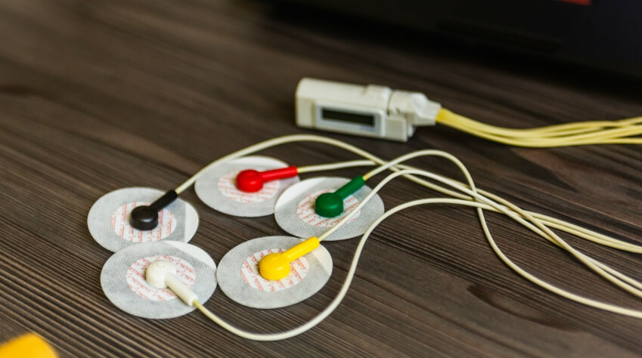
Fig. 6.1. ECG Patch

6.2 Abnormal ECG Detection Unit
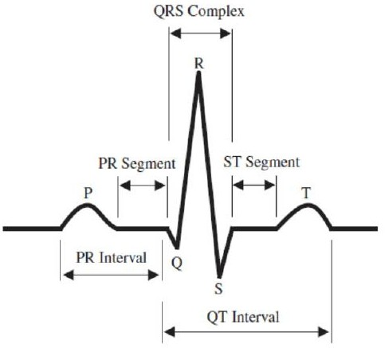
To detect the abnormal ECG signal, firstly the normal ECG should be analyzed to get the parameters of it. Once the various parameters and their normal values are known, they can be easily compared with the parameters of the incoming ECG signal from the electrodes to decide whether it is abnormal or not. Fig. 6.2 shows an ECG signal.

Fig. 6.2. ECG Signal

TABLE 6.1. Various ECG parameters and their normal values

S.No | Parameter | Normal Value
1 | QRS Complex | 80-100 ms
2 | PR Interval | 120-200ms
3 | QT Interval | 0.3-0.6s
4 | PR Segment | 50-120 ms
5 | ST Segment | 80-120 ms
6 | RR Interval | 0.6-1.2s

The next stage in the implementation of ECG is the classification part wherein the received ECG signal is compared with the normal ECG to decide whether the patient is having any abnormality, indicating arrhythmias. Comparison of ECG signals can be done either by using the analog voltage comparator, which compares the two given input signals, and provides an output either high or low, depending on the inputs. To use the ECG sensor module with Arduino, you need to install the appropriate software libraries. The AD8232 library provides functions for initializing the chip, reading the ECG signal, and calculating the heart rate. The ECG signal is typically displayed on a computer screen using a processing program.
Applications:
- The ECG sensor module for Arduino has a wide range of applications, including:
- Portable heart rate monitors
- ECG telemetry systems
- Fitness trackers
- Wearable health devices
- Remote patient monitoring systems

The decision can also be made based on neural networks. The field of machine learning can be comfortably used for the detection of abnormal ECG. It is seen that, neural networks can be trained with a set of data and then if a test data is given to the neural network, it will be able to ciome to a conclusion, depending on its training. In a way, the neural network remembers the data that it got trained. When a testing data comes, it can actually compare it with the trained data and can decide the result. This can be used for abnormal ECG detection too. For that, the neural network has to be trained with a normal ECG data, as well as an abnormal ECG data. Training should be given repeatedly to the neural network, so that the output of the testing set becomes very accurate. Once the neural network is trained and is ready, the collected ECG data should be sent to the neural network and the network will decide whether the ECG is normal or abnormal based on its training knowledge. This is one of the very recent trends that can be used to detect the abnormal ECG. Machine learning can be implemented in a variety of methods. One way is by utilizing the MATLAB neural network tool, which can train on a set of data and can easily give the decision on the testing data set. But exporting the ECG data to the neural network should happen without any delay.

6.3 Theraphy / Defibrillating Unit
The defibrillating unit contains a biphasic voltage waveform generator. Since biphasic waveforms were found to have much higher efficiency as per the discussion in the previous sections, the biphasic waveform is generated using Pulse Width Modulation (PWM). The PWM circuit was designed to have a low frequency biphasic waveform. The PWM circuit is shown in the fig. 6.3.


Fig. 6.3. Theraphy Pad

6.4 AD8232 ECG SENSOR
This sensor is a cost-effective board used to measure the electrical activity of the heart. This electrical activity can be charted as an ECG or Electrocardiogram and output as an analog reading. ECGs can be extremely noisy, the AD8232 Single Lead Heart Rate Monitor acts as an op amp to help obtain a clear signal from the PR and QT Intervals easily.
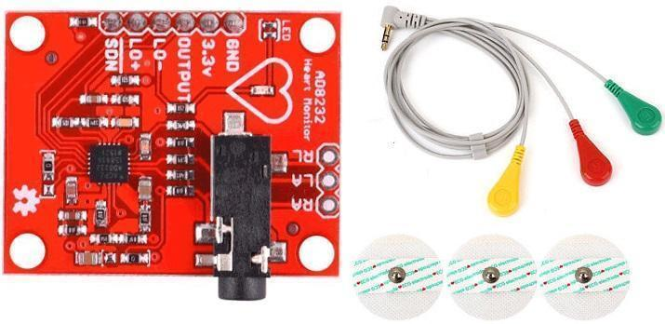
Fig. 6.4. AD8232 ECG SENSOR

The AD8232 is an integrated signal conditioning block for ECG and other biopotential measurement applications. It is designed to extract, amplify, and filter small biopotential signals in the presence of noisy conditions, such as those created by motion or remote electrode placement.

The AD8232 module breaks out nine connections from the IC that you can solder pins, wires, or other connectors to. SDN, LO+, LO-, OUTPUT, 3.3V, GND provide essential pins for operating this monitor with an Arduino or other development board. Also provided on this board are RA (Right Arm), LA (Left Arm), and RL (Right Leg) pins to attach and use your own custom sensors. Additionally, there is an LED indicator light that will pulsate to the rhythm of a heart beat.

6.5 AD8232 ECG Sensor Placement on Body
It is recommended to snap the sensor pads on the leads before application to the body. The closer to the heart the pads are, the better the measurement. The cables are color coded to help identify proper placement.
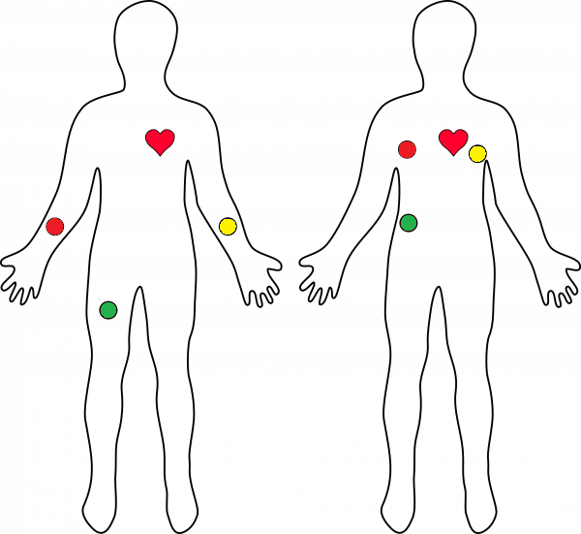
Fig. 6.5. ECG Sensor Placement on Body

Red: RA (Right Arm)
Yellow: LA (Left Arm)
Green: RL (Right Leg)

FEATURES:
- Operating Voltage - 3.3V
- Analog Output
- Leads-Off Detection
- Shutdown Pin
- LED Indicator
- 3.5mm Jack for Biomedical Pad Connection or Use 3 pin header

6.6 ESP32 Nodemcu
ESP32 is designed for mobile, wearable electronics, and Internet-of-Things (IoT) applications. It features all the state-of-the-art characteristics of low-power chips, including fine-grained clock gating, multiple power modes, and dynamic power scaling. For instance, in a low-power IoT sensor hub application scenario, ESP32 is woken up periodically only when a specified condition is detected. Low-duty cycle is used to minimize the amount of energy that the chip expends. The output of the power amplifier is also adjustable, thus contributing to an optimal trade-off between communication range, data rate and power consumption.
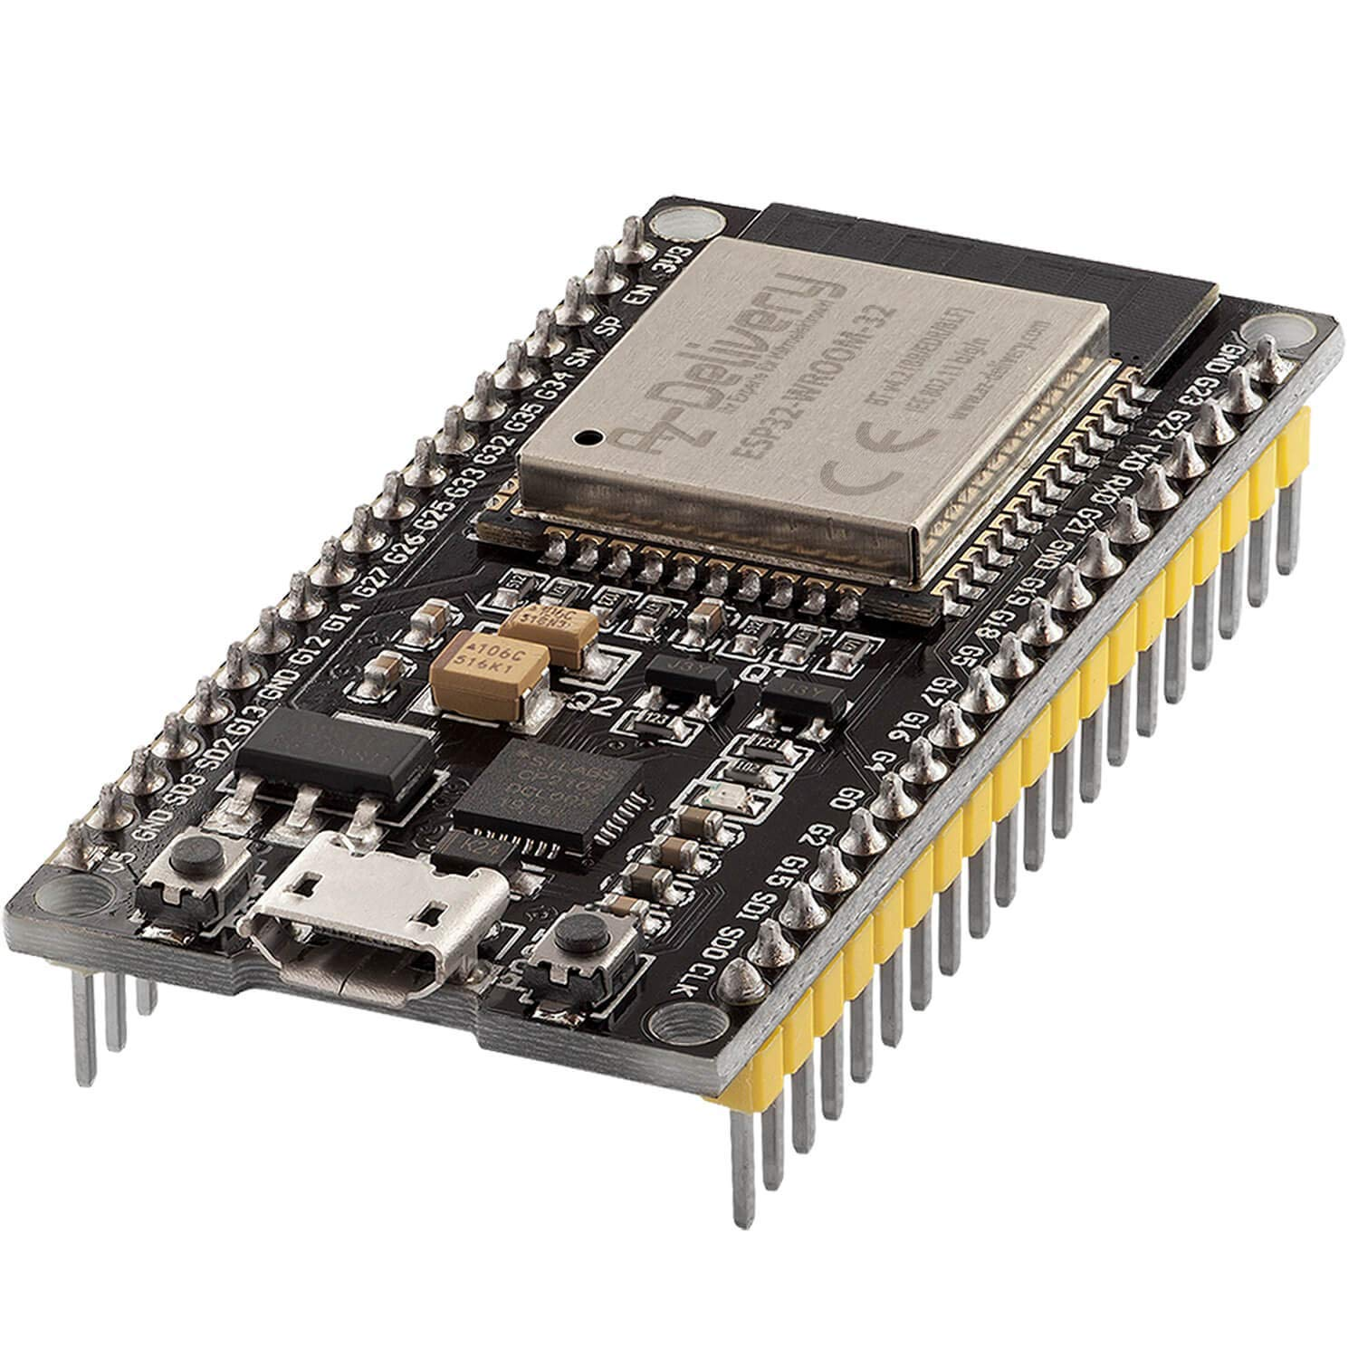
Fig. 6.6. ESP32 Nodemcu

ESP32 is a highly-integrated solution for Wi-Fi-and-Bluetooth IoT applications, with around 20 external components. ESP32 integrates an antenna switch, RF balun, power amplifier, low-noise receive amplifier, filters, and power management modules. As such, the entire solution occupies minimal Printed Circuit Board (PCB) area. ESP32 uses CMOS for single-chip fully-integrated radio and baseband, while also integrating advanced calibration circuitries that allow the solution to remove external circuit imperfections or adjust to changes in external conditions. As such, the mass production of ESP32 solutions does not require expensive and specialized Wi-Fi testing equipment.

WiFi Key Features
• 802.11 b/g/n
• 802.11 n (2.4 GHz), up to 150 Mbps
• WMM
• TX/RX A-MPDU, RX A-MSDU
• Immediate Block ACK
• Defragmentation
• Automatic Beacon monitoring (hardware TSF)
• 4 × virtual Wi-Fi interfaces
• Simultaneous support for Infrastructure Station, SoftAP, and Promiscuous modes Note that when ESP32 is in Station mode, performing a scan, the SoftAP channel will be changed.
• Antenna diversity.

Bluetooth Key Features
• Compliant with Bluetooth v4.2 BR/EDR and Bluetooth LE specifications
• Class-1, class-2 and class-3 transmitter without external power amplifier
• Enhanced Power Control
• +9 dBm transmitting power
• NZIF receiver with –94 dBm Bluetooth LE sensitivity
• Adaptive Frequency Hopping (AFH)
• Standard HCI based on SDIO/SPI/UART
• High-speed UART HCI, up to 4 Mbps
• Bluetooth 4.2 BR/EDR Bluetooth LE dual mode controller
• Synchronous Connection-Oriented/Extended (SCO/eSCO)
• CVSD and SBC for audio codec
• Bluetooth Piconet and Scatternet
• Multi-connections in Classic Bluetooth and Bluetooth LE
• Simultaneous advertising and scanning.

MCU and Advanced Features
• Xtensa® single-/dual-core 32-bit LX6 microprocessor(s)
• CoreMark® score: – 1 core at 240 MHz: 504.85 CoreMark; 2.10 CoreMark/MHz – 2 cores at 240 MHz: 994.26 CoreMark; 4.14 CoreMark/MHz
• 448 KB ROM , 520 KB SRAM , 16 KB SRAM in RTC , QSPI supports multiple flash/SRAM chips

Clocks and Timers
• Internal 8 MHz oscillator with calibration
• Internal RC oscillator with calibration
• External 2 MHz ~ 60 MHz crystal oscillator (40 MHz only for Wi-Fi/Bluetooth functionality)
• External 32 kHz crystal oscillator for RTC with calibration
• Two timer groups, including 2 × 64-bit timers and 1 × main watchdog in each group
• One RTC timer
• RTC watchdog
Advanced Peripheral Interfaces
• 34 × programmable GPIOs
• 12-bit SAR ADC up to 18 channels 2 × 8-bit DAC , 10 × touch sensors , 4 × SPI , 2 × I2S ,2 × I2C ,3 × UART, 1 host (SD/eMMC/SDIO), 1 slave (SDIO/SPI)
• Ethernet MAC interface with dedicated DMA and IEEE 1588 support
• TWAI®, compatible with ISO 11898-1 (CAN Specification 2.0) • RMT (TX/RX)
• Motor PWM
• LED PWM up to 16 channels
• Hall sensor

Security
• Secure boot
• Flash encryption
• 1024-bit OTP, up to 768-bit for customers
• Cryptographic hardware acceleration:
• AES, Hash (SHA-2), RSA, ECC, Random Number Generator (RNG)

Applications (A Nonexhaustive List)
• Generic Low-power IoT Sensor Hub , Generic Low-power IoT Data Loggers , Cameras for Video Streaming , Over-the-top (OTT) Devices , Speech Recognition , Image Recognition , Mesh Network
• Home Automation – Light control – Smart plugs – Smart door locks
• Smart Building – Smart lighting – Energy monitoring
• Industrial Automation – Industrial wireless control – Industrial robotics
• Smart Agriculture – Smart greenhouses – Smart irrigation – Agriculture robotics
• Audio Applications – Internet music players – Live streaming devices – Internet radio players – Audio headsets
• Health Care Applications – Health monitoring – Baby monitors
• Wi-Fi-enabled Toys – Remote control toys – Proximity sensing toys – Educational toys
• Wearable Electronics – Smart watches – Smart bracelets
• Retail & Catering Applications – POS machines – Service robots

6.7 BUZZER
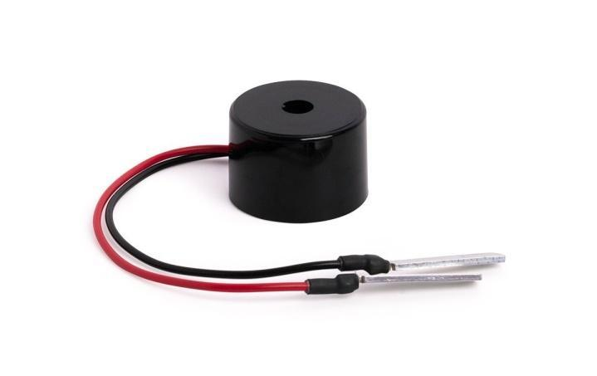
A buzzer or beeper is an audio signalling device, which may be mechanical, electromechanical, or piezoelectric (piezo for short). Typical uses of buzzers and beepers include alarm devices, timers, and confirmation of user input such as a mouse click or keystroke

Fig. 6.7. BUZZER

A buzzer is a small yet efficient component to add sound features to our project/system. It is very small and compact 2-pin structure hence can be easily used on breadboard, Perf Board and even on PCBs which makes this a widely used component in most electronic applications.
There are two types are buzzers that are commonly available. The one shown here is a simple buzzer which when powered will make a Continuous Beweeps sound, the other type is called a readymade buzzer which will look bulkier than this and will produce a Beep. Beep. Beep. Sound due to the internal oscillating circuit present inside it. But, the one shown here is most widely used because it can be customised with help of other circuits to fit easily in our application.
This buzzer can be used by simply powering it using a DC power supply ranging from 4V to 9V. A simple 9V battery can also be used, but it is recommended to use a regulated +5V or +6V DC supply. The buzzer is normally associated with a switching circuit to turn ON or turn OFF the buzzer at required time and require interval.

6.8 Relay
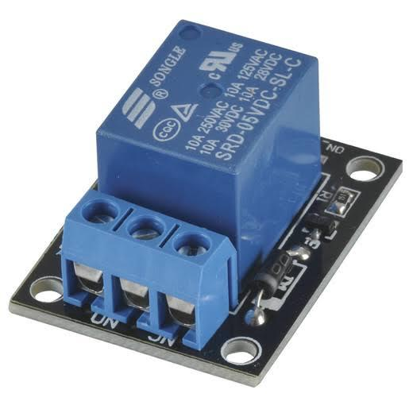
A relay is an electromagnetic switch that is used to turn on and turn off a circuit by a low power signal, or where several circuits must be controlled by one signal.

Fig. 6.8. Relay
The main operation of a relay comes in places where only a low-power signal can be used to control a circuit. It is also used in places where only one signal can be used to control a lot of circuits. The application of relays started during the invention of telephones. They played an important role in switching calls in telephone exchanges. They were also used in long distance telegraphy. They were used to switch the signal coming from one source to another destination. After the invention of computers they were also used to perform Boolean and other logical operations. The high end applications of relays require high power to be driven by electric motors and so on. Such relays are called contactors

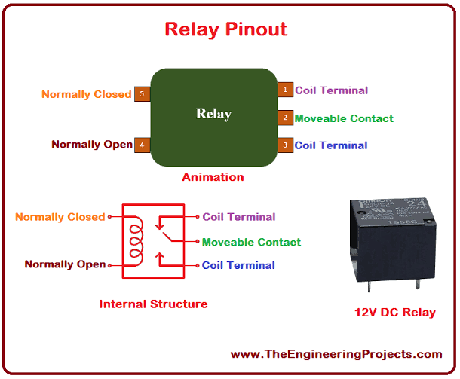

Fig. 6.9. Relay circuit

Working
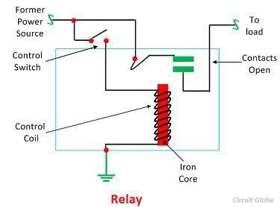
It works on the principle of an electromagnetic attraction. When the circuit of the relay senses the fault current, it energizes the electromagnetic field which produces the temporary magnetic field.
This magnetic field moves the relay armature for opening or closing the

Fig. 6.10. Relay Working
connections. The small power relay has only one contact, and the high power relay has two contacts for opening the switch.
The inner section of the relay is shown in the figure below. It has an iron core which is wound by a control coil. The power supply is given to the coil through the contacts of the load and the control switch. The current flow through the coil produces the magnetic field around it.
Due to this magnetic field, the upper arm of the magnet attracts the lower arm. Hence close the circuit, which makes the current flow through the load. If the contact is already closed, then it moves oppositely and hence opens the contacts.

Relay Basics
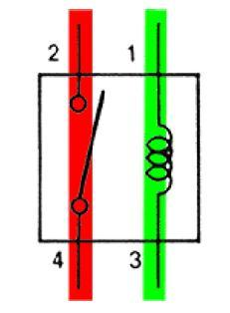
The basics for all the relays are the same. Take a look at a 4 – pin relay shown below. There are two colours shown. The green color represents the control circuit and the red colour represents the load circuit. A small control coil is connected onto the control circuit. A switch is connected to the load. This switch is controlled by the coil in the control circuit. Now let us take the different step that occurs in a relay.

Fig. 6.9. Relay circuit

- Energized Relay (ON)
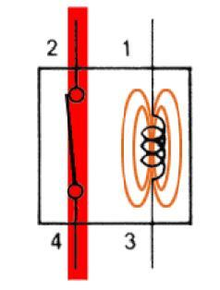
As shown in the circuit, the current flowing through the coils represented by pins 1 and 3 causes a magnetic field to be aroused. This magnetic field causes the closing of the pins 2 and 4. Thus the switch
Fig. 6.10. Energized Relay (ON)

plays an important role in the relay working. As it is a part of the load circuit, it is used to control an electrical circuit that is connected to it. Thus, when the electrical relay in energized the current flow will be through the pins 2 and 4.

- De – Energized Relay (OFF)
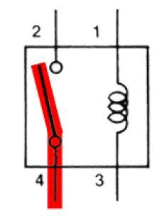
As soon as the current flow stops through pins 1 and 3, the relay switch opens and thus the open circuit prevents the current flow through

pins 2 and 4. Thus the relay becomes de-energized and thus in of position.

In simple, when a voltage is applied to pin 1, the electromagnet activates, causing a magnetic field to be developed, which goes on to close the pins 2 and 4 causing a closed circuit. When there is no voltage on pin 1, there will be no electromagnetic force and thus no magnetic field. Thus the switches remain open.

Pole and Throw
Relays have the exact working of a switch. So, the same concept is also applied. A relay is said to switch one or more poles. Each pole has contacts that can be thrown in mainly three ways. They are
- Normally Open Contact (NO) – NO contact is also called a make contact. It closes the circuit when the relay is activated. It disconnects the circuit when the relay is inactive.

- Normally Closed Contact (NC) – NC contact is also known as break contact. This is opposite to the NO contact. When the relay is activated, the circuit disconnects. When the relay is deactivated, the circuit connects.

- Change-over (CO) / Double-throw (DT) Contacts – This type of contacts are used to control two types of circuits. They are used to control a NO contact and also a NC contact with a common terminal. According to their type they are called by the names break before make and make before break contacts.
Relays can be used to control several circuits by just one signal. A relay switches one or more poles, each of whose contacts can be thrown by energizing the coil.

Relays are also named with designations like
- Single Pole Single Throw (SPST) – The SPST relay has a total of four terminals. Out of these two terminals can be connected or disconnected. The other two terminals are needed for the coil to be connected.

- Single Pole Double Throw (SPDT) – The SPDT relay has a total of five terminals. Out of these two are the coil terminals. A common terminal is also included which connects to either of two others.

- Double Pole Single Throw (DPST) – The DPST relay has a total of six terminals. These terminals are further divided into two pairs. Thus they can act as two SPST’s which are actuated by a single coil. Out of the six terminals two of them are coil terminals.

- Double Pole Double Throw (DPDT) – The DPDT relay is the biggest of all. It has mainly eight relay terminals. Out of these two rows are designed to be change over terminals. They are designed to act as two SPDT relays which are actuated by a single coil.

6.9 9V BATTERY
This is General purpose 9V Original HIW marked Non-Rechargeable Battery for all your project and application needs. As we experienced the use of this battery in our testing lab for various purpose, we can assure you the best quality, long life and genuineness of this battery among all options available in the market at this cost. Its Universal 9V battery size and connecting points; it is useful in many DIY projects as well as household applications and they can easily be replaced and installed; the same as you would an AA battery or an AAA battery. Whether you need a new battery for your applications like a Flashlight, Portable Phone Charger wireless doorbell, Wireless audio transmitter-receiver systems or your kid’s toys, etc. Even if you are looking for a long-lasting, reliable option for your sensor devices like a smoke detector, everyone needs a good 9-volt battery every once in a while. It’s also a great idea to keep an extra 9 volt batteries around in case of an emergency. That’s why we’ve found one of the best 9-volt battery available.

CHAPTER 7
RESULT AND DISCUSSION
7.1 ECG SENSOR
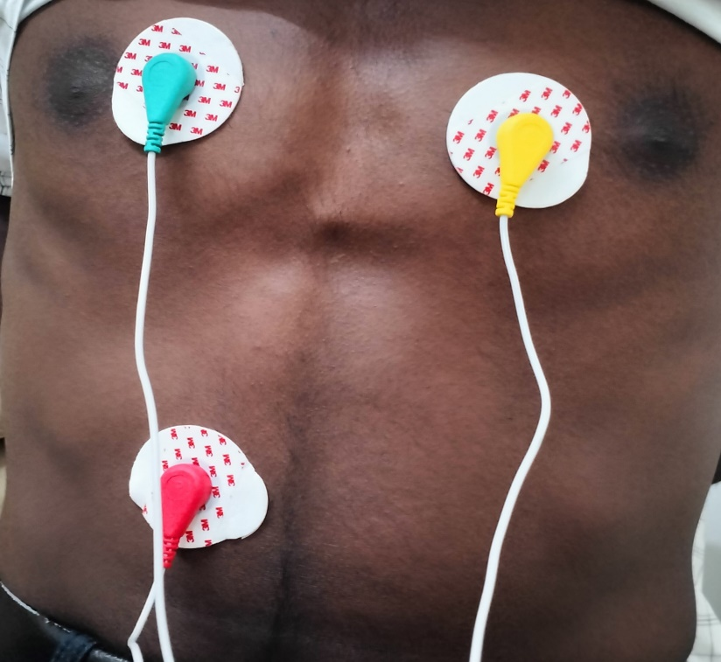
The ECG sensor module consists of three electrodes that are attached to the skin to measure the electrical activity of the heart. The three electrodes are placed on the right arm, left arm, and left leg. The electrical signals generated by the heart are amplified and filtered to remove any unwanted noise. The filtered signal is then digitized and transmitted to the Arduino board.
The ECG sensor module for Arduino uses the AD8232 chip, which is a low-power, single-lead ECG analog front end. The chip is capable of amplifying

Fig. 7.1. ECG Sensor Placed in Body

and filtering the ECG signal, as well as providing a right-leg drive circuit to
reduce the common-mode noise. The AD8232 chip communicates with the Arduino board through a serial interface, which makes it easy to integrate with other sensors and devices.

The ECG sensor module for Arduino is a low-cost and easy-to-use solution for measuring the electrical activity of the heart. The AD8232 chip provides amplification, filtering, and noise reduction, making it an ideal choice for portable medical devices. With its flexible software and easy integration with other sensors, the ECG sensor module for Arduino has a wide range of applications in healthcare and fitness industries.
The electrode is applied to the electrocardiogram sensor for monitoring the cardiac signals for five consecutive days without detaching while doing various full-day activities such as relaxing, exercising, showering, and sleeping. This study suggests a modular setup of the electrodes and the cardiac signal processing unit for activating the device when cardiac monitoring is required.

7.2 Electrocardiography Wave
At every beat, the heart is depolarized to trigger its contraction. This electrical activity is transmitted throughout the body and can be picked up on the skin. This is the principle behind the ECG. An ECG machine records this activity via electrodes on the skin and displays it graphically. An ECG involves attaching 10 electrical cables to the body: one to each limb and six across the chest.

Output

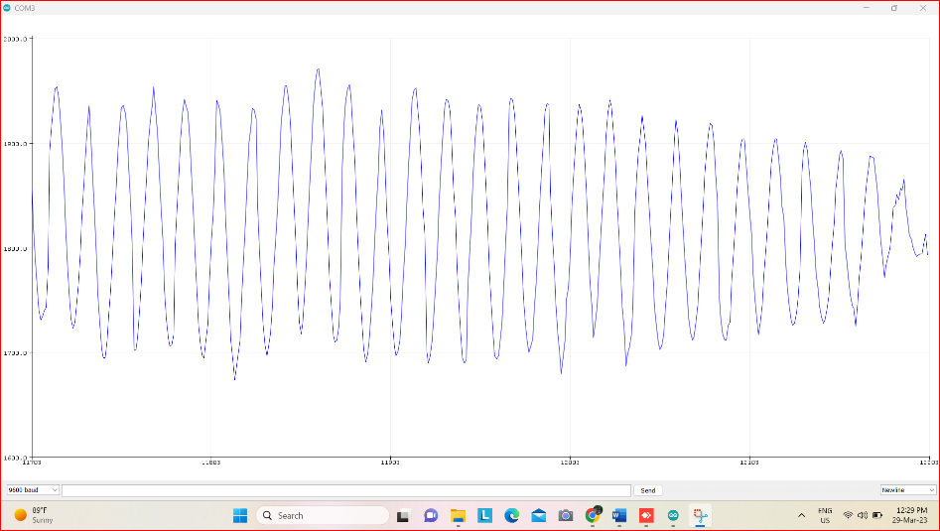

Fig. 7.2. Output Wave in Normal

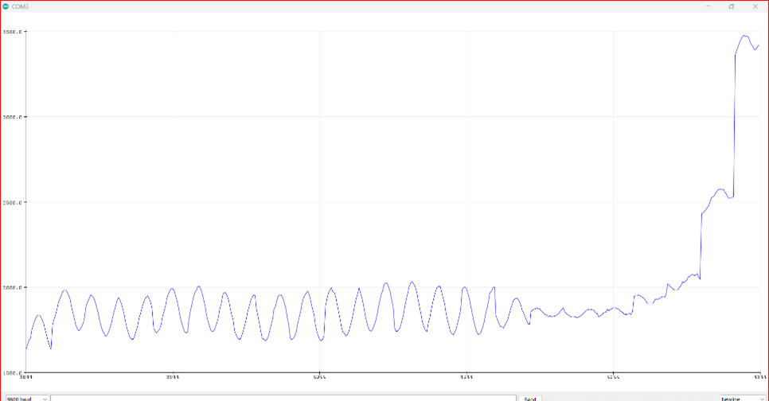
Fig. 7.3. Output Wave in Abnormal

CHAPTER 8
APPENDICES
8.1 Code
int buzzer=4;
void setup() {
// initialize the serial communication:
Serial.begin(9600);
pinMode(34, INPUT); // Setup for leads off detection LO +
pinMode(35, INPUT); // Setup for leads off detection LO -

pinMode(16, OUTPUT); // Setup for relay1
pinMode(17, OUTPUT); // Setup for relay2
pinMode(buzzer,OUTPUT);//setup for buzzer

}

void loop() {

if((digitalRead(34) == 1)||(digitalRead(35) == 1))
{
Serial.println('!');
digitalWrite(16,HIGH);
digitalWrite(17,HIGH);
digitalWrite(buzzer,HIGH);
delay(2000);
digitalWrite(16,LOW);
digitalWrite(17,LOW);
digitalWrite(buzzer,LOW);
delay(1000);
}
else{
// send the value of analog input 0:
Serial.println(analogRead(32));
}
//Wait for a bit to keep serial data from saturating
delay(1);
}

CHAPTER 9
CONCLUSION
Thus the project initially focused on analyzing the various existing defibrillator design along with their review status. Various strategies in those existing designs were discussed and then future improvisations for those existing designs were also suggested. Then one of the recent developments in the field of defibrillator design – Smart Wearable Cardioverter Defibrillator (SWCD) was discussed along with the block diagram of implementation. The wearable defibrillator design can use any one of the ECG electrode assembly, either the flexible electrode or the silver woven fabric methodology. Any of these implementations would work fine, because the research outputs have proven the same. The implementation of SWCD was divided into three parts – ECG collection unit, Abnormality detection unit and then the therapy unit. Each unit was clearly described along with the design methodology for the circuits. Thus the project has proposed a working model for the internal circuitry of an SWCD along with the suggestions for the wearable material. Thus, the detailed description of the defibrillator design trends and the design of an SWCD were explained.

References

1 .Zijlstra, J. A., Bekkers, L. E., Hulleman, M., Beesems, S. G., &Koster, R. W. (2017). Automated external defibrillator and operator performance in out-of-hospital cardiac arrest. Resuscitation, 118, 140-146.

2.Ohta, S., Harikae, K., Sekine, K., &Nemoto, M. (2014). How, when, and where have rental automated external defibrillators been used in Japan?.Journal of cardiology, 64(2), 117-120.

3.Reek, Sven, et al. "Clinical efficacy of a wearable defibrillator in acutely terminating episodes of ventricular fibrillation using biphasic shocks." Pacingand clinical electrophysiology 26.10 (2003): 2016-2022.

4.Atkins, James M. "Emergency medical service systems in acute cardiac care: state of the art." Circulation 74.6 Pt 2 (1986): IV4-8.

5.Sedgwick, M. L., et al. "Efficacy of out of hospital defibrillation by ambulance technicians using automated external defibrillators. The Heartstart Scotland Project." Resuscitation 24.1 (1992): 73-87.
6.Eisenberg, Mickey S., et al. "Cardiac arrest and resuscitation: a tale of 29 cities." Annals of emergency medicine 19.2 (1990): 179-186.
7.Irusta, U., Ruiz, J., de Gauna, S. R., EftestØl, T., & Kramer- Johansen, J. (2009). A least mean-square filter for the estimation of the cardiopulmonary resuscitation artifact based on the frequency of the compressions. IEEE Transactions on Biomedical Engineering, 56(4), 1052-1062.
8.Chen, W. Y., Huang, S. Y., Wang, M., & Cheng, S. S. (2017). Location indicators of automated external defibrillator electrode patches using image processing techniques. Computers & Electrical Engineering, 58, 525-536.
9.Ackerman, E. "The Defibrillator Drone Is Another Good Drone Idea But Will It Work?." IEEE Spectrum, October 30 (2014).
10.Samani, H., & Zhu, R. (2016). Robotic automated external defibrillator ambulance for emergency medical service in smart cities. IEEE Access, 4, 268-283.
11.Liu, J. J., Gui, L., Chen, Z. M., Xu, K. Y., Li, Y., Zhang, J., & Zhou, L. J. (2015). Effectiveness of combining manual external defibrillator and automated external defibrillator training for third- year nurse students. International Journal of Nursing Sciences, 2(1), 105-109.
12.Stewart, John A. "Focused nurse-defibrillation training: a simple and cost-effective strategy to improve survival from in-hospital cardiac arrest." Scandinavian journal of trauma, resuscitation and emergency medicine 18.1 (2010): 42.
13.Haines, David E. "Automated external defibrillators and the law of unintended consequences." JAMA 304.19 (2010): 2178-2179.
14.Amann, A., Tratnig, R., &Unterkofler, K. (2007). Detecting ventricular fibrillation by time-delay methods. IEEE Transactions on Biomedical Engineering, 54(1), 174-177.
15.Roppolo, Lynn P., et al. "Prospective, randomized trial of the effectiveness and retention of 30-min layperson training for cardiopulmonary resuscitation and automated external defibrillators: The American Airlines Study." Resuscitation 74.2 (2007): 276-285.
16.Nguyen, M. T., Van Nguyen, B., & Kim, K. (2017). Shockable rhythm diagnosis for automated external defibrillators using a modified variational mode decomposition technique. IEEE Transactions on Industrial Informatics.
17.Cleland JG, Swedberg K, Follath F, “A Survey of the Quality of Care Among Patients with Heart Failure in Europe. Part 1:Patient Characteristics and Diagnosis,” The Euro Heart Failure Survey Programme, pp. 442-463, 2003.
18.Shah, R.C.; Yarvis, M, “Characteristics of on-body 802.15.4 networks,” 2nd IEEE Workshop on Wireless Mesh Networks, pp.138-139, September 2006
19.CentersforDiseaseControlandPrevention,AtlantaGA,USA.[Online].Available:http://www.cdc.gov/heartdisease/facts.ht mJ. Clerk Maxwell, A Treatise on Electricity and Magnetism, 3rd ed., vol. 2. Oxford: Clarendon, 1892, pp.68-73.
20.KamyaYekehYazdandoost and Ryuji Kohno, “Channel Modelfor Body Area Network(BAN),” 802.15-08-0780-09-0006, April 2009.
21.Kim, Dong-Sun, et al. "Implementation of implantable cardioverter defibrillator." Communications and Information Technology, 2009. ISCIT 2009. 9th International Symposium on. IEEE, 2009.
22.Rapsang, Amy G., and Prithwis Bhattacharyya. "Pacemakers and implantable cardioverter defibrillators-general and anesthetic considerations." RevistaBrasileira de Anestesiologia 64.3 (2014): 205-214.
23.M. Mirowski, “Termination of malignad ventricular arrhythmiaswith an implanted automatic defibrillator in human beings,”NewEngland J. Med., vol. 303, p. 322, 1980.
24.L. A.Geddes et al., “Engineering and physiological considerations of direct capacitor discharge ventricular defibrillation,”Med. Biol. Eng., vol. 9, p. 188, 1971.
25.Halperin, Daniel, et al. "Pacemakers and implantable cardiac defibrillators: Software radio attacks and zero-power defenses." Security and Privacy, 2008. SP 2008. IEEE Symposium on. IEEE, 2008.
26.Ploux, Sylvain, et al. "Towards eradication of inappropriate therapies for ICD lead failure by combining comprehensive remote monitoring and lead noise alerts." Journal of cardiovascular electrophysiology (2018).
27.Bilchick, Kenneth C., et al. "Seattle heart failure and proportional risk models predict benefit from implantable cardioverter- defibrillators." Journal of the American College of Cardiology 69.21 (2017): 2606-2618.
28.Camm, John, Helmut Klein, and SeahNisam. "The cost of implantable defibrillators: perceptions and reality." European heart journal 28.4 (2006): 392-397.
29.Swerdlow, Charles, KalyanamShivkumar, and Jianxin Zhang. "Determination of the upper limit of vulnerability using implantable cardioverter-defibrillator electrograms." Circulation 107.24 (2003): 3028-3033.
30.Pacifico, Antonio, et al. "Prevention of implantable-defibrillator shocks by treatment with sotalol." New England Journal of Medicine 340.24 (1999): 1855-1862.
31.Gruetzmann, Anna, Stefan Hansen, and Jörg Müller. "Novel dry electrodes for ECG monitoring." Physiological measurement 28.11 (2007): 1375
32.Feldman, Arthur M., et al. "Use of a wearable defibrillator in terminating tachyarrhythmias in patients at high risk for sudden death: results of WEARIT/BIROAD." Pacing and clinical electrophysiology 27.1 (2004): 4-9.
33.Benvegar, Carl E., Gregory D. Brink, and Dennis E. Ochs. "Intelligent battery and method for providing an advance low battery warning for a battery powered device such as a defibrillator." U.S. Patent No. 5,721,482. 24 Feb. 1998.
34.Lamond, Pierre R., and Bruno Strul. "Portable defibrillator with disposable power pack." U.S. Patent No. 5,658,316. 19 Aug. 1997.

35.Bowers, Kyle R. "Automated external defibrillator (AED) system with multiple patient wireless monitoring capability for use in mass casualty incidents." U.S. Patent Application No. 11/978,261.

36.Freeman, Gary A. "Semiautomatic defibrillator with heart rate alarm driven by shock advisory algorithm." U.S. Patent No. 5,391,187. 21 Feb. 1995.
37.Fischell, Robert E. "Recorder with patient alarm and service request systems suitable for use with automatic implantable defibrillator." U.S. Patent No. 4,295,474. 20 Oct. 1981.
38.Dillon, Katie A., Steven J. Szymkiewicz, and Thomas E. Kaib. "Evaluation of the effectiveness of a wearable cardioverter defibrillator detection algorithm." Journal of electrocardiology 43.1 (2010): 63-67.

39.Klein, Helmut U., et al. "Bridging a temporary high risk of sudden arrhythmic death. Experience with the wearable cardioverter defibrillator (WCD)." Pacing and Clinical Electrophysiology 33.3 (2010): 353-367.

40.Martinsen, ØrjanGrøttem, et al. "Bioimpedance-based respiration monitoring with a defibrillator." IEEE Trans. Biomed. Engineering 61.6 (2014): 1858-1862.

41.Baker Jr, Ross G., Richard V. Calfee, Edward A. Haluska, and Stephen J. Whistler. "Implantable cardiac stimulator with automatic gain control and bandpass filtering in feedback loop."
U.S. Patent 4,880,004, issued November 14, 1989.
42.Jenkins, Janice M., and Stephanie A. Caswell. "Detection algorithms in implantable cardioverter defibrillators." Proceedings of the IEEE 84.3 (1996): 428-445.

43.Caselli, Monica, Stefano Severi, and Aldo Casaleggio. "Monophasic vs. biphasic stimulation of single cardiomyocite cell: A simulation study." Computing in Cardiology, 2010. IEEE, 2010.

44.Rubinstein, Jay T., et al. "Analysis of monophasic and biphasic electrical stimulation of nerve." IEEE Transactions on biomedical engineering 48.10 (2001): 1065-1070.

45.Qu, F., et al. "Comparison of three biphasic defibrillation waveforms: Gurvich waveform is more efficient." Engineering in Medicine and Biology, 2002. 24th Annual Conference and the Annual Fall Meeting of the Biomedical Engineering Society EMBS/BMES Conference, 2002. Proceedings of the Second Joint. Vol. 2. IEEE, 2002.

46.DAMIANO Jr, RALPH J. "Implantable cardioverter defibrillators: current status and future directions." Journal of cardiac surgery 7.1 (1992): 36-57.

47.Tang, Wanchun, et al. "The effects of biphasic and conventional monophasic defibrillation on postresuscitation myocardial function." Journal of the American College of Cardiology 34.3 (1999): 815-822.

48.VanAlem, Anouk P., et al. "A prospective, randomised and blinded comparison of first shock success of monophasic and biphasic waveforms in out-of-hospital cardiac arrest." Resuscitation 58.1 (2003): 17-24.

49.Baker Jr, R. G., Whistler, S. J., Ideker, R. E., Calfee, R. V., &Haluska, E. A. (1989). U.S. Patent No. 4,821,723. Washington, DC: U.S. Patent and Trademark Office.

50.Wyse, D. G., Kavanagh, K. M., Gillis, A. M., Mitchell, L. B., Duff, H. J., Sheldon, R. S., ... &Mehra, R. (1993). Comparison of biphasic and monophasic shocks for defibrillation using a nonthoracotomy system. American Journal of Cardiology, 71(2), 197-202.
51.Schwarz, B., Bowdle, T. A., Jett, G. K., Mair, P., Lindner, K. H., Aldea, G. S., ... & Chapman, F. W. (2003). Biphasic shocks compared with monophasic damped sine wave shocks for direct ventricular defibrillation during open heart surgery. Anesthesiology: The Journal of the American Society of Anesthesiologists, 98(5), 1063-1069.

52.Chlaihawi, AmerAbdulmahdi, et al. "Development of printed and flexible dry ECG electrodes." Sensing and Bio-Sensing Research 20 (2018): 9-15.

53.Ma, Zuwei, et al. "Surface engineering of electrospun polyethylene terephthalate (PET) nanofibers towards development of a new material for blood vessel engineering." Biomaterials 26.15 (2005): 2527-2536.

54.Zięba, Janusz, et al. "Textronic clothing to ECG measurement." Medical Measurements and Applications Proceedings (MeMeA), 2011 IEEE International Workshop on. IEEE, 2011.G: A technology vision," Dec. 2013

